Requirement Analysis
Technology Stack
Date: | 29/10/2025
Team ID: | NM2025TMID01821
Project Name: | Streamlining Ticket Assignment for Efficient Support Operations
Maximum Marks: | 4 Marks

Technical Architecture:
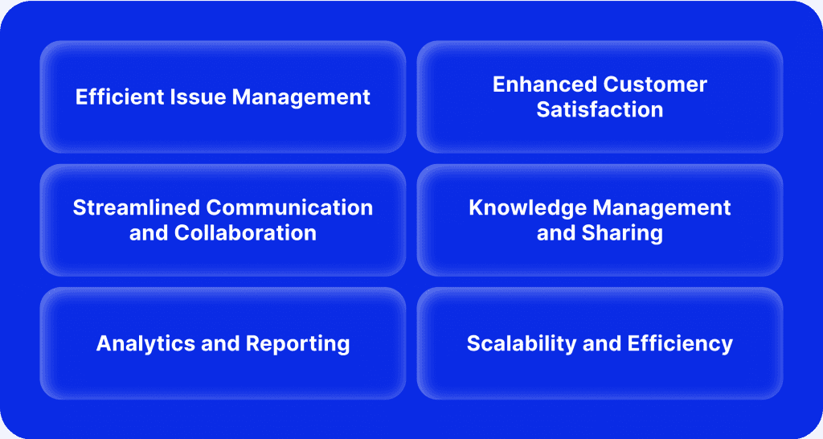

Table-1: Components & Technologies:
S.No | Component | Description | Technology
1. | User Interface | Managers, agents, and customers interact via web dashboards and portals in ServiceNow | ServiceNow Web UI, Service Portal
2. | Application Logic-1 | Skills-based routing engine that matches ticket categories with agent expertise profiles | Script Include, Business Rules, GlideRecord
3. | Application Logic-2 | Workload balancing algorithm that checks agent capacity and prevents overload | Server Scripts, GlideRecord Queries
4. | Application Logic-3 | Priority queue management that routes urgent tickets to senior agents immediately | ServiceNow Flow Designer, Business Rules
5. | Application Logic-4 | Escalation processor that monitors unassigned tickets and triggers alerts after thresholds | Scheduled Jobs, ServiceNow Workflows
6. | Application Logic-5 | Notification engine that sends assignment alerts to agents, customers, and managers | ServiceNow Notifications, Email Events
7. | Database | Stores incident records, agent profiles, skills data, and assignment tracking | ServiceNow CMDB, Incident Tables, Custom Tables
8. | Cloud Database | Managed by ServiceNow cloud backend with automatic scaling and backup | ServiceNow Cloud Database (MySQL-based)
9. | File Storage | Audit logs and system logs stored internally with retention policies | ServiceNow System Logs, Audit Tables
10. | External API-1 | Email service integration for notifications and alerts | REST API, ServiceNow Email Integration
11. | External API-2 | Optional integration with external analytics or BI tools for advanced reporting | REST API, ServiceNow Integration Hub
12. | Machine Learning Model | Future enhancement: AI-powered predictive assignment based on historical patterns | Not applicable for current phase
13. | Infrastructure (Server / Cloud) | Hosted and managed on ServiceNow SaaS platform with high availability | ServiceNow Cloud (SaaS), Load-Balanced Instances

Table-2: Application Characteristics:
S.No | Characteristics | Description | Technology
1. | Open-Source Frameworks | Not applicable (ServiceNow is proprietary platform) | -
2. | Security Implementations | Role-based access control, ACLs for data protection, secure scripts, encrypted data storage | ACLs, Scoped Applications, OAuth 2.0, SAML
3. | Scalable Architecture | SaaS-based platform with horizontal scalability via ServiceNow cloud architecture | ServiceNow Cloud Architecture, Auto-Scaling
4. | Availability | Highly available with ServiceNow cloud hosting, 99.5% uptime SLA, disaster recovery enabled | Load-Balanced ServiceNow Instances, Multi-Region
5. | Performance | Optimized via asynchronous flows, indexed database tables, and efficient script execution | GlideRecord Optimization, Background Scripts, Caching
6. | Reliability | 97%+ automatic assignment success rate with error handling and fallback mechanisms | Business Rule Validation, Exception Handling
7. | Monitoring & Analytics | Real-time dashboards with Performance Analytics, audit logging, and KPI tracking | Performance Analytics, ServiceNow Reporting
8. | Integration Capability | REST/SOAP APIs for external system integration, webhook support | REST API, Integration Hub, Web Services
9. | Compliance & Audit | Complete audit trails with timestamps, user tracking, GDPR/CCPA compliance support | sys_audit Table, Audit Logs, Data Privacy Controls
10. | Maintainability | Modular architecture with reusable Script Includes, easy rule updates, version control | Script Includes, Update Sets, Version Control

